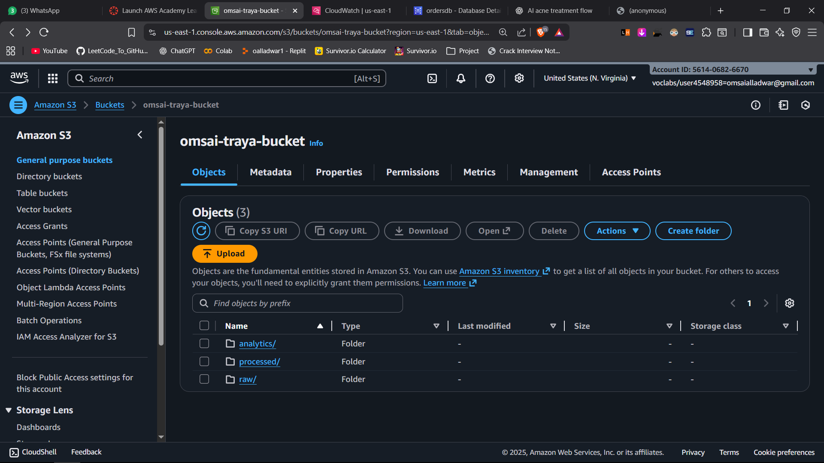

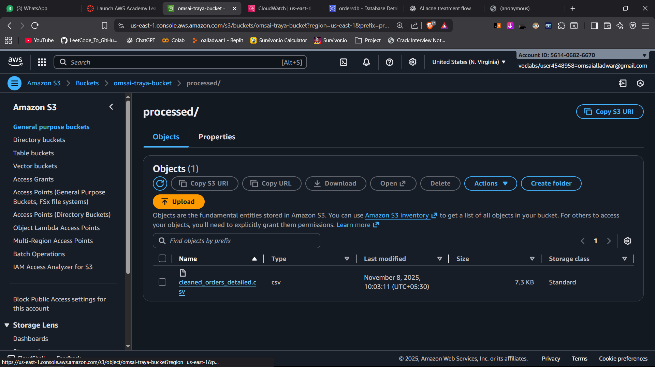

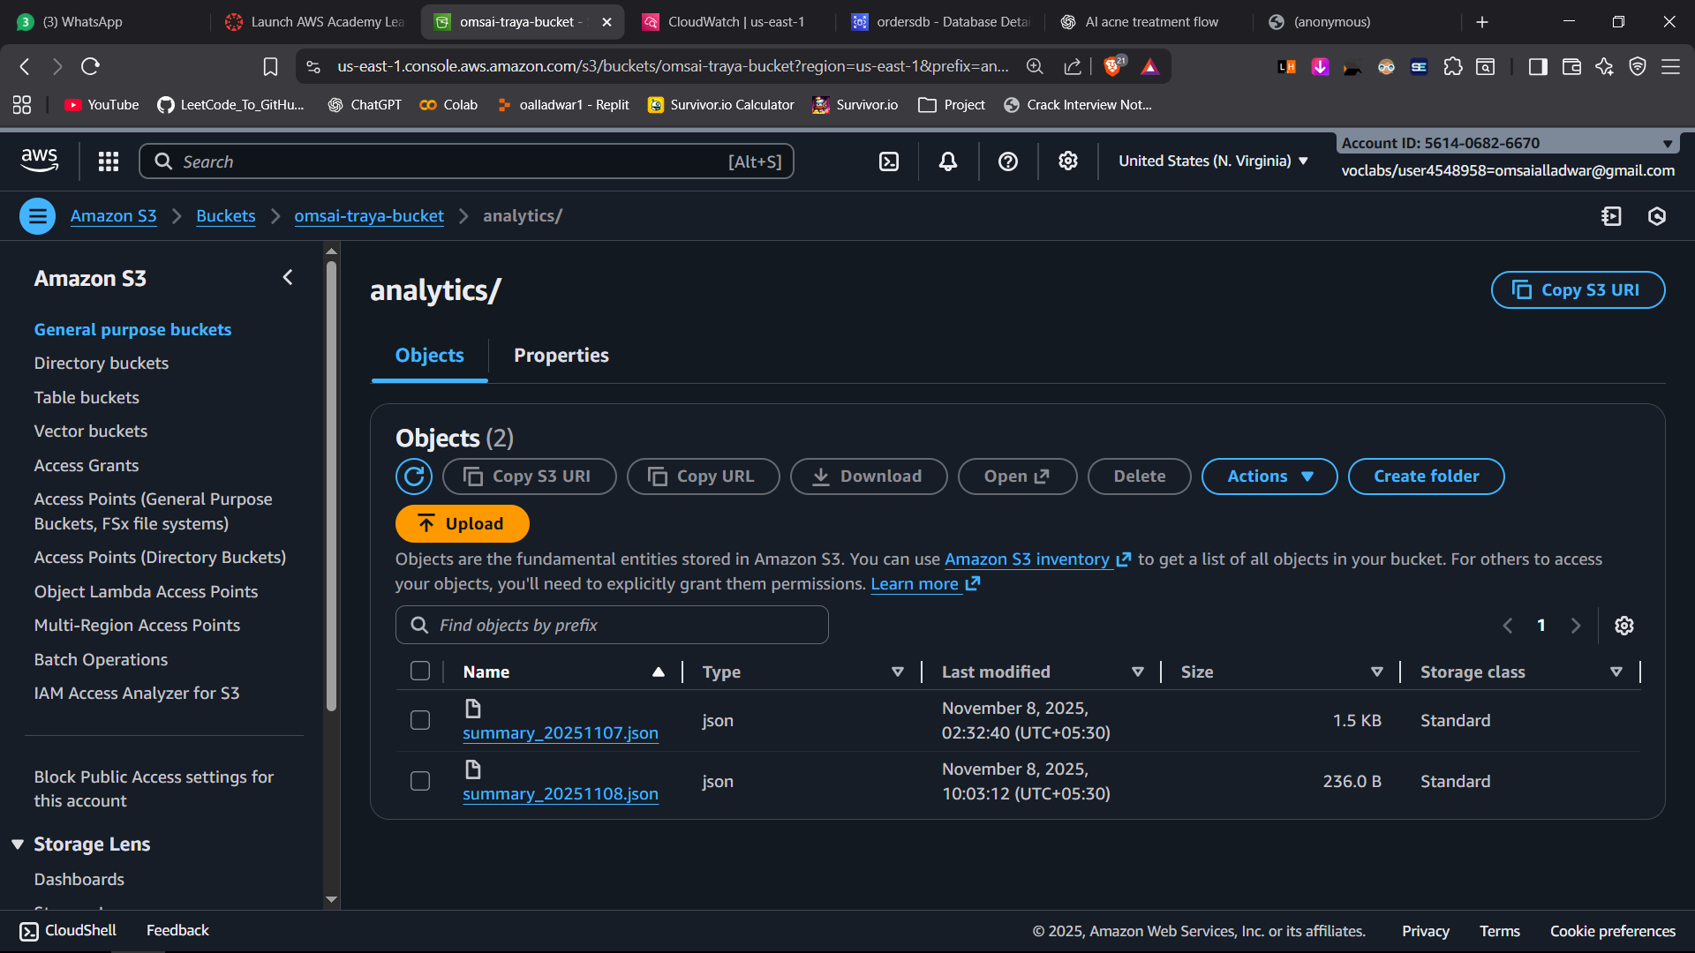

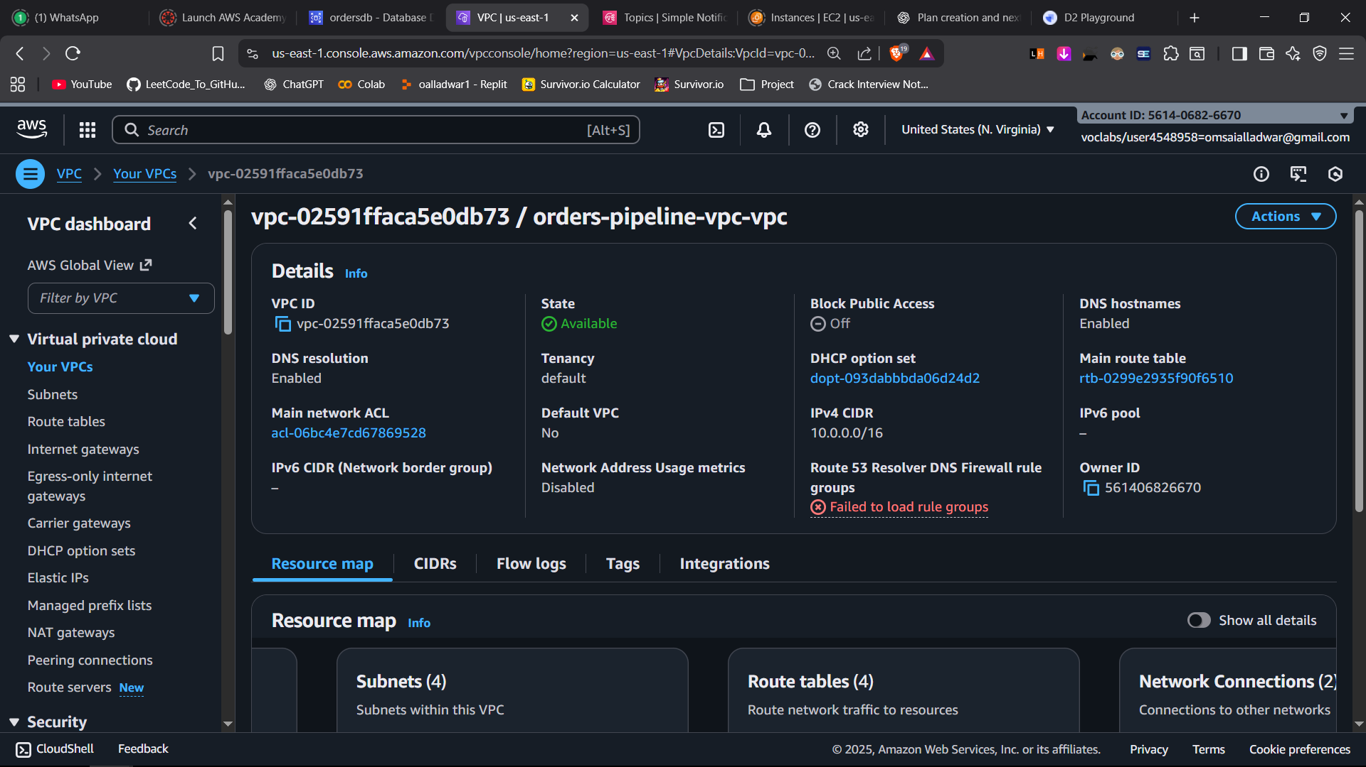

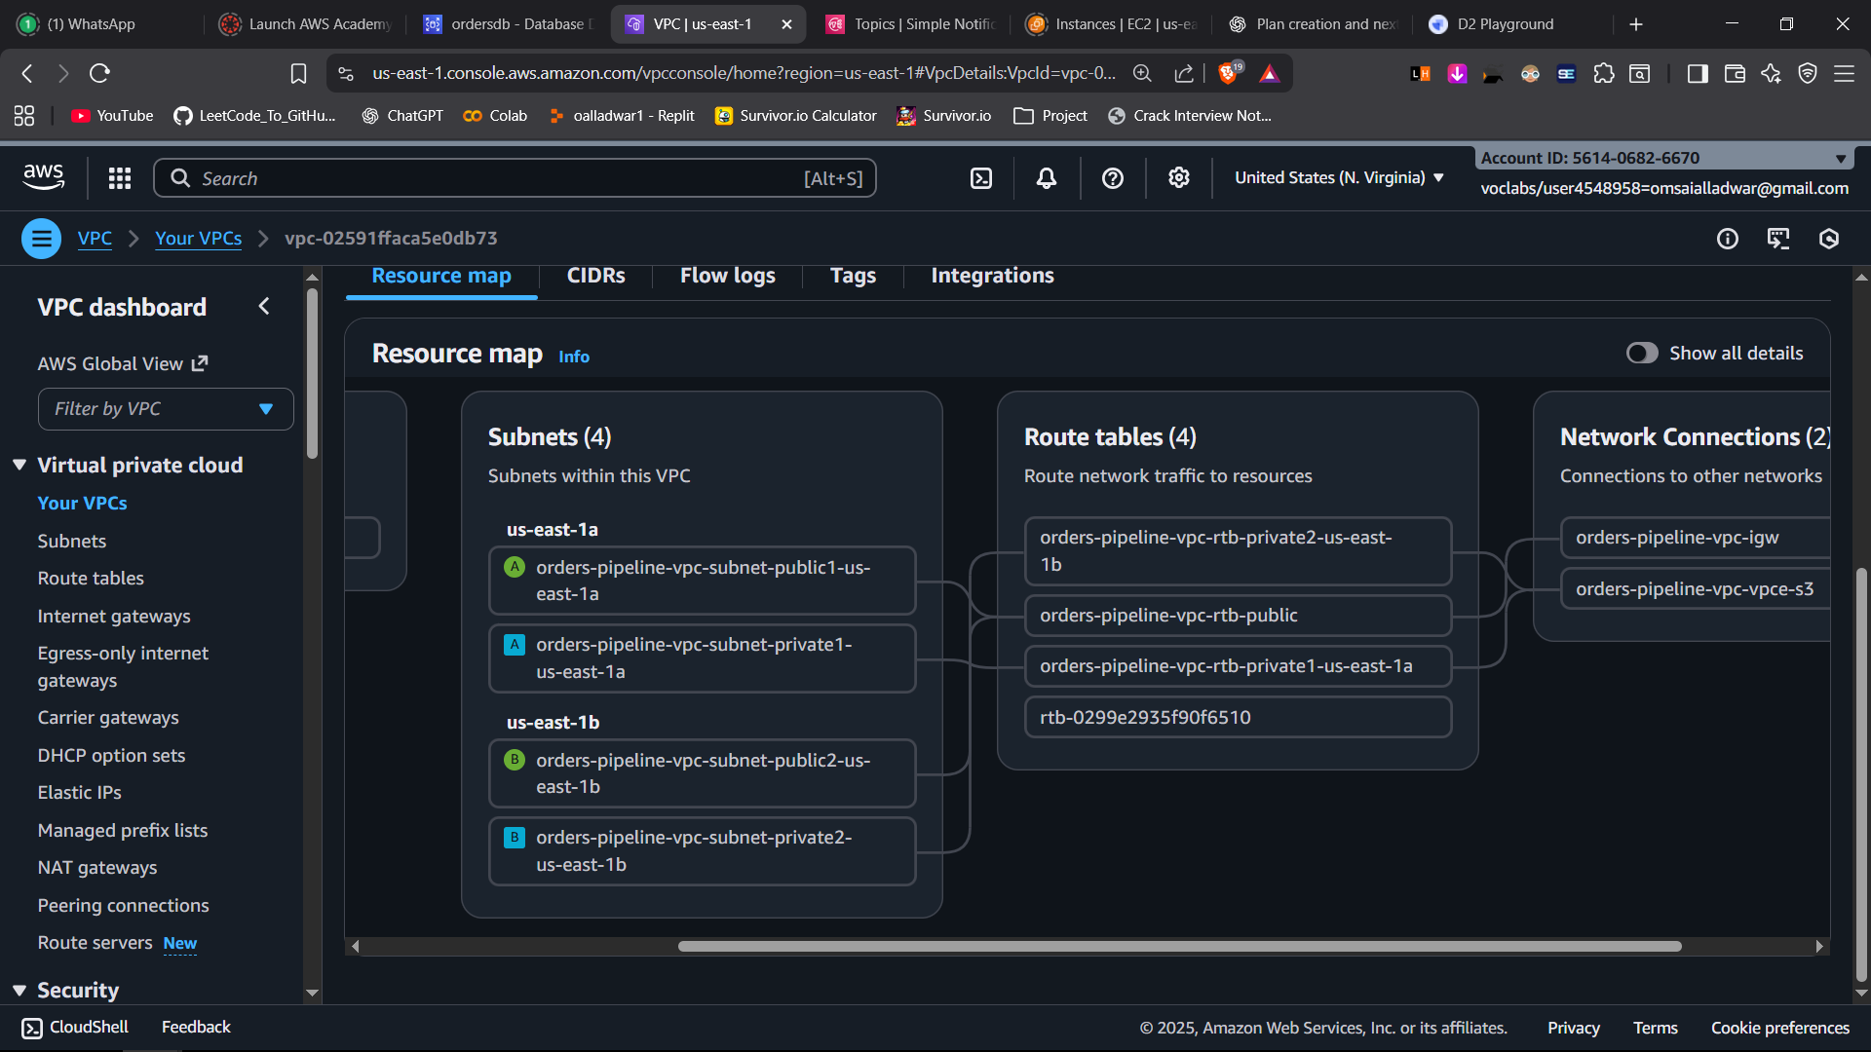

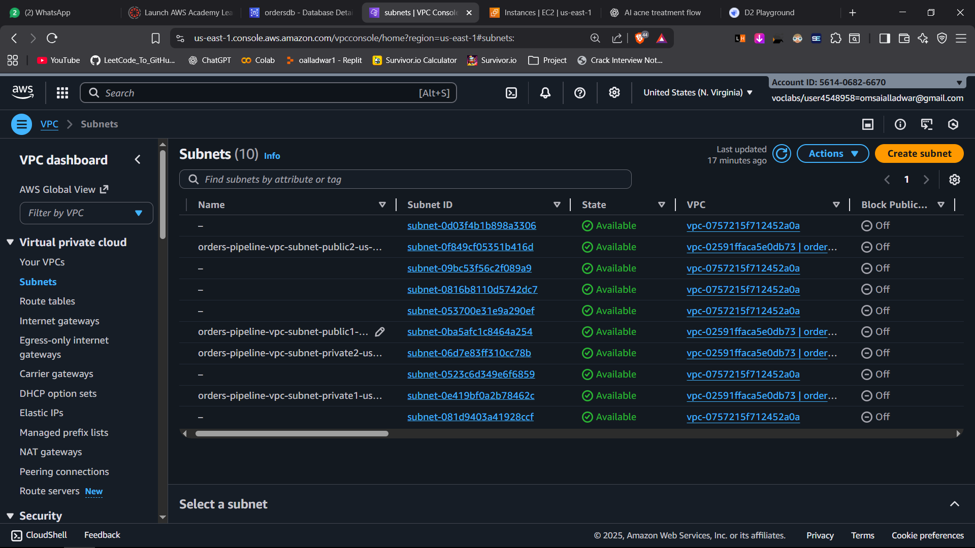

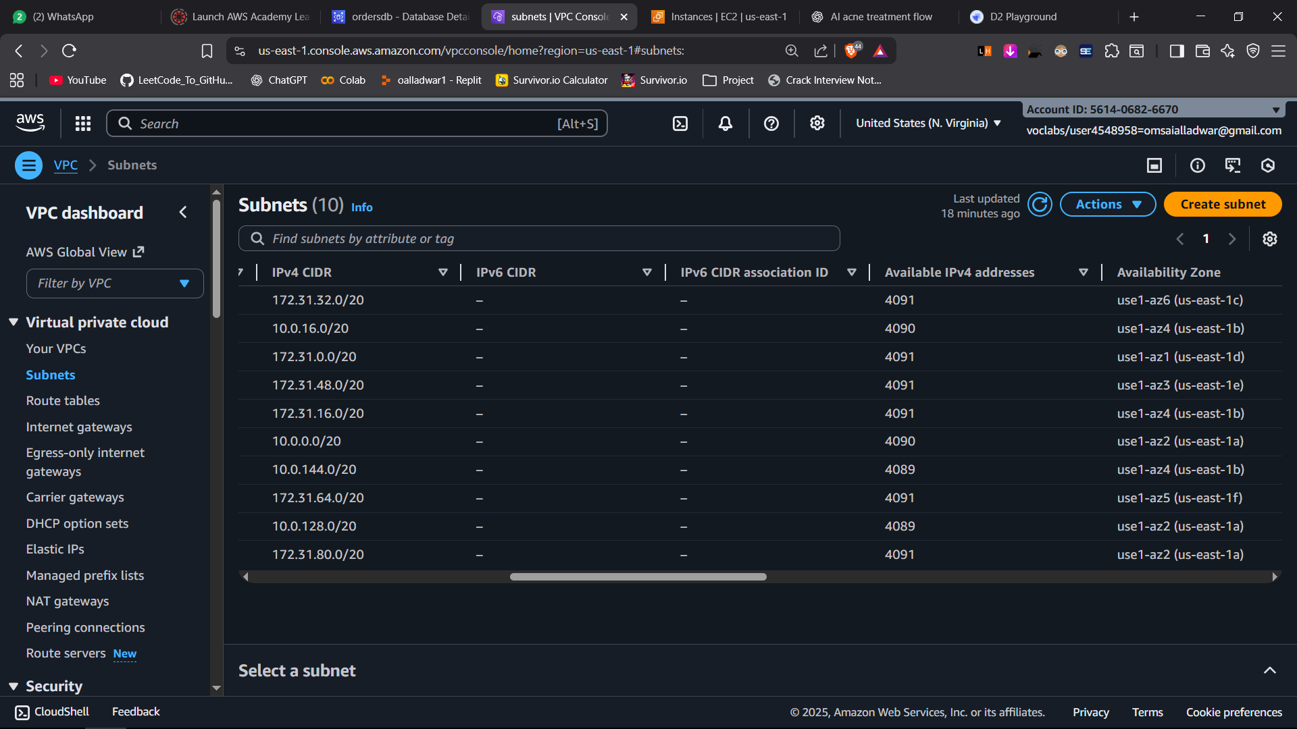

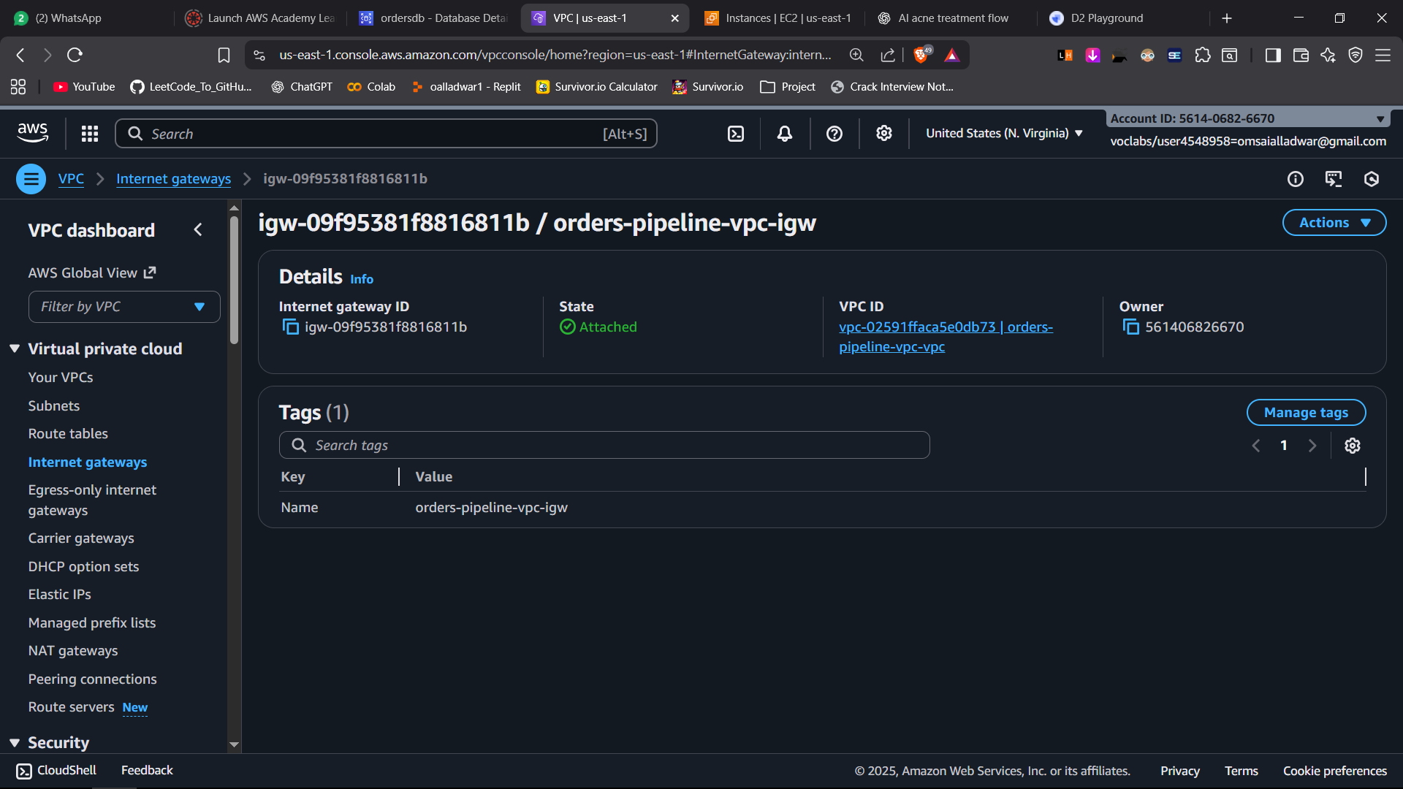

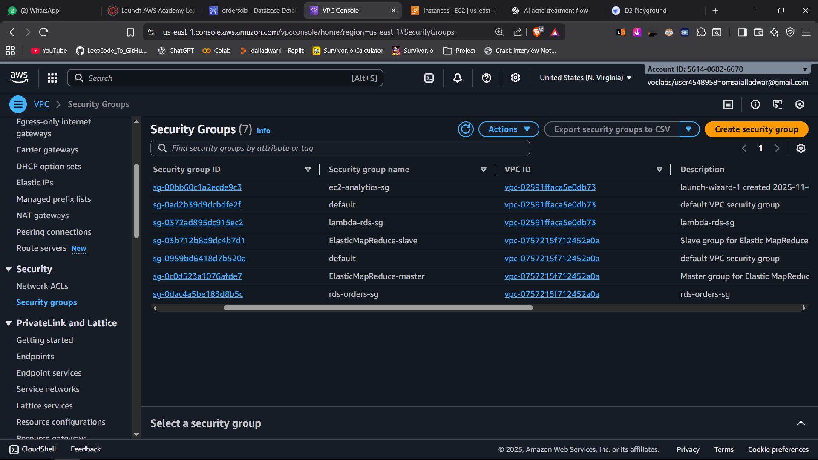

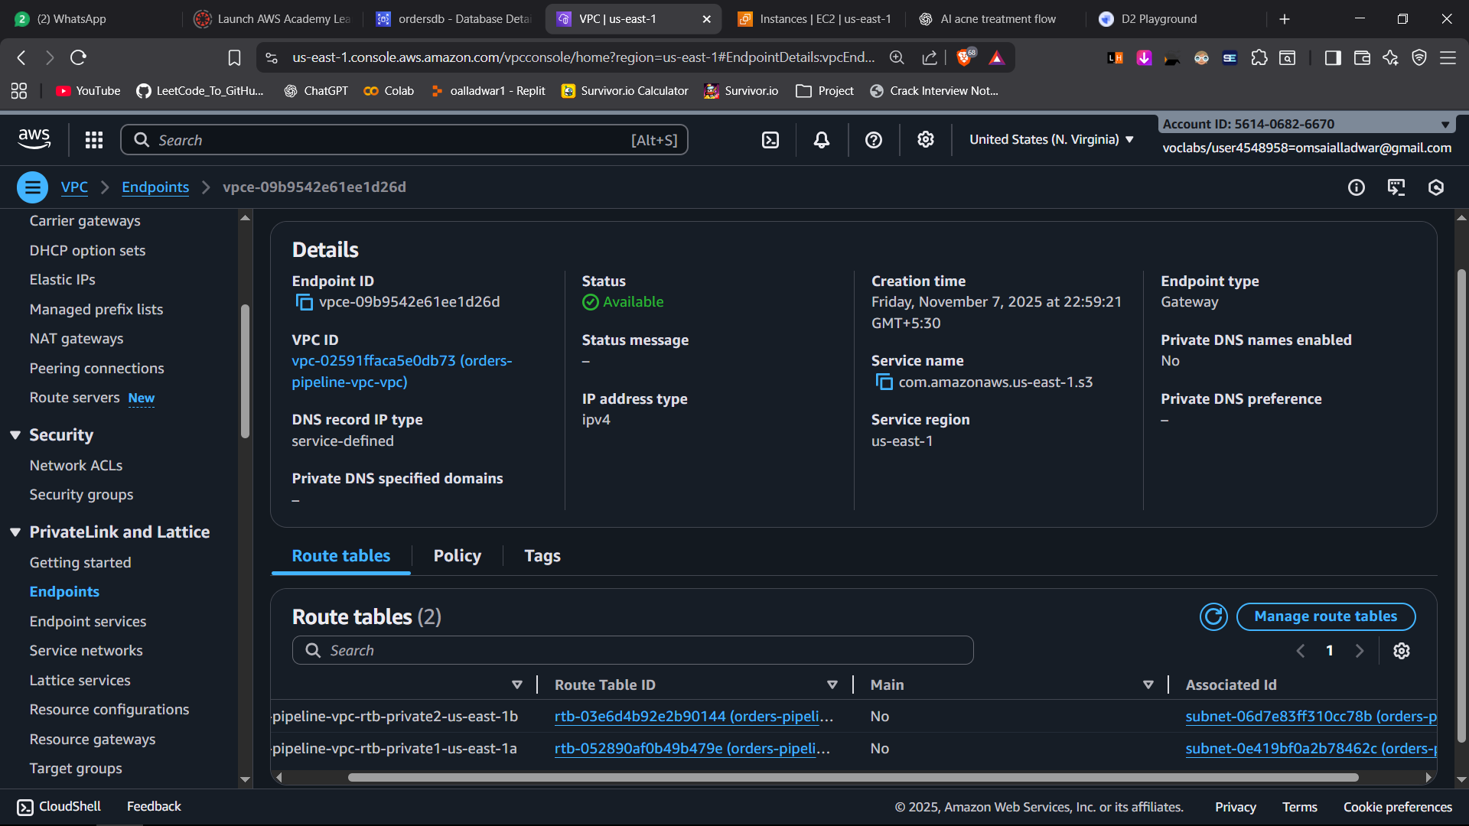

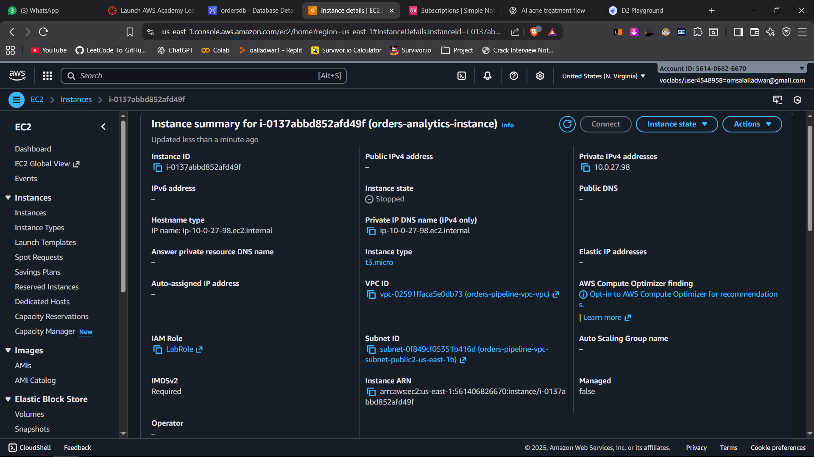

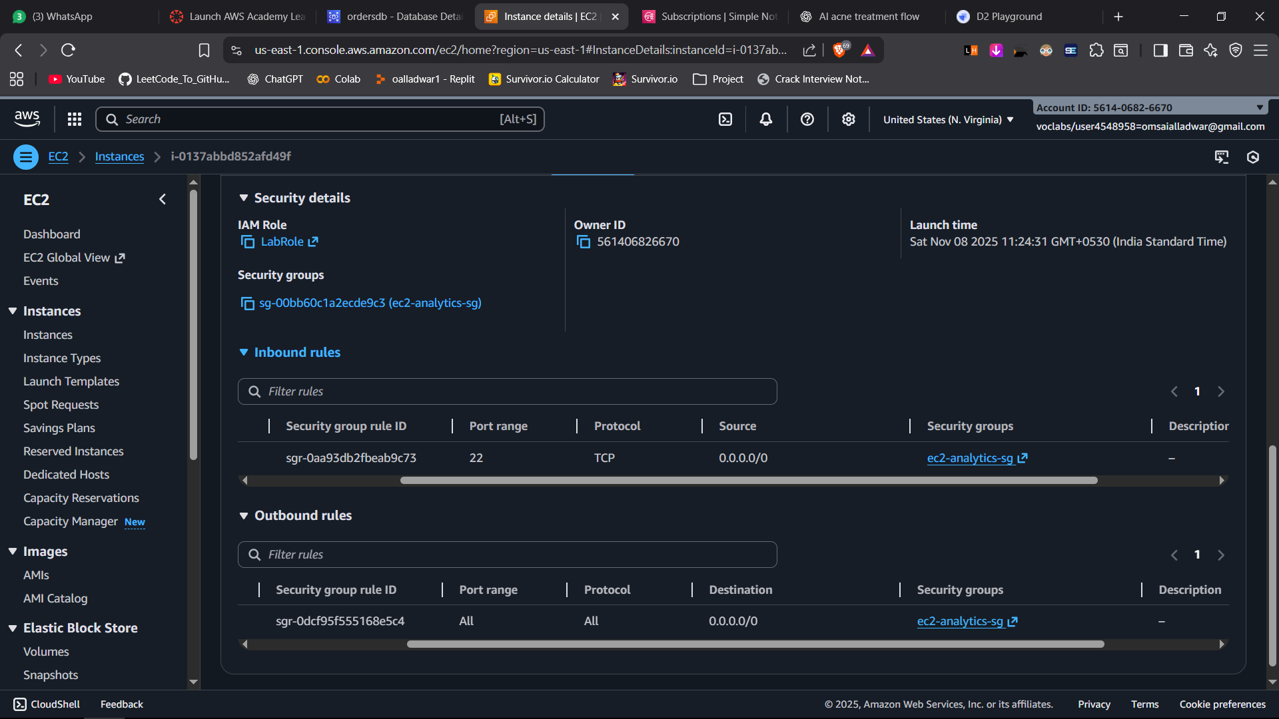

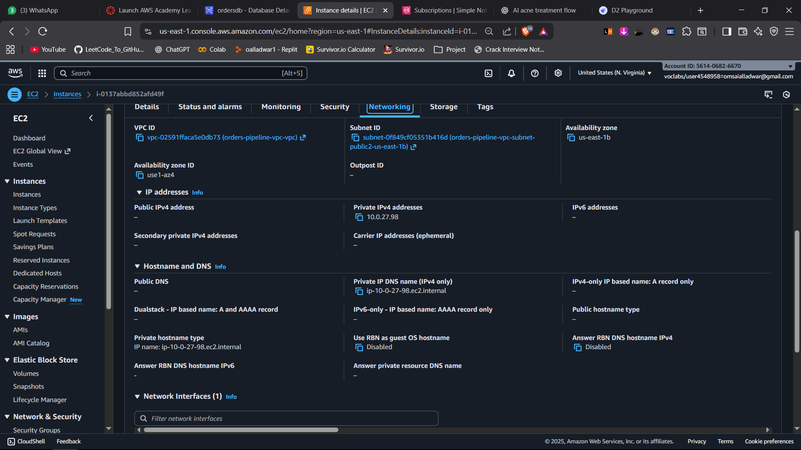

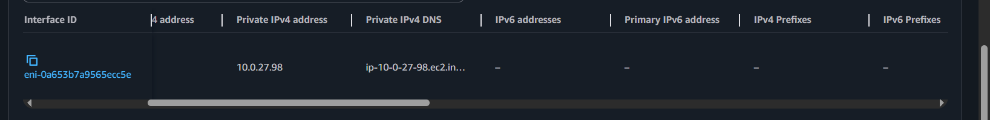

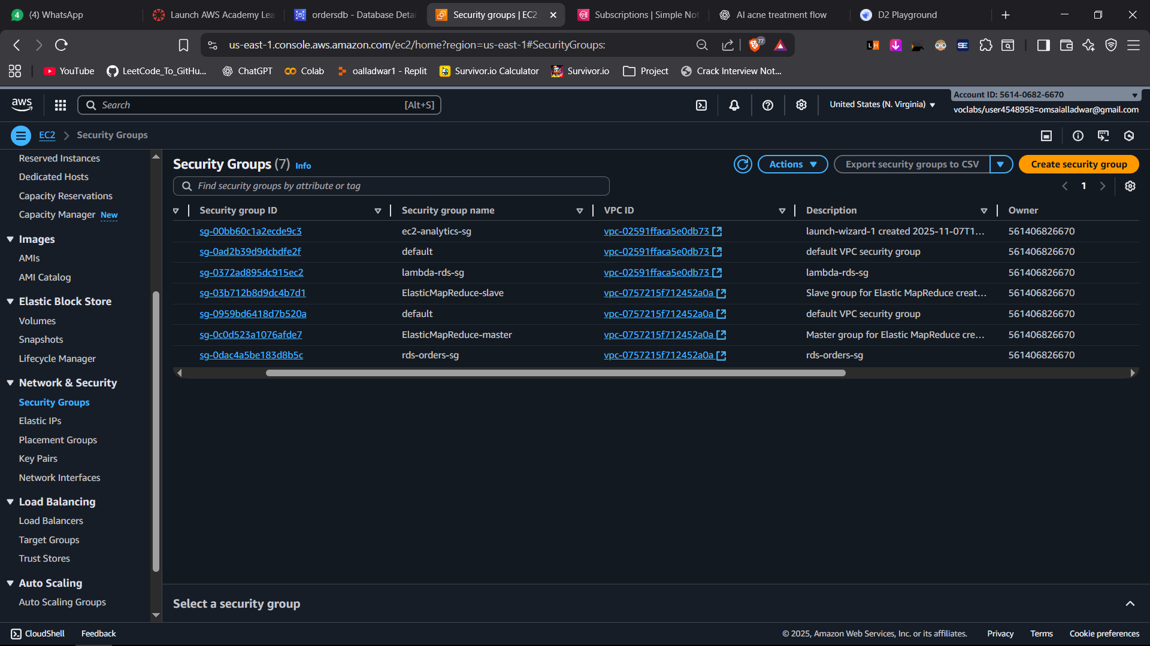

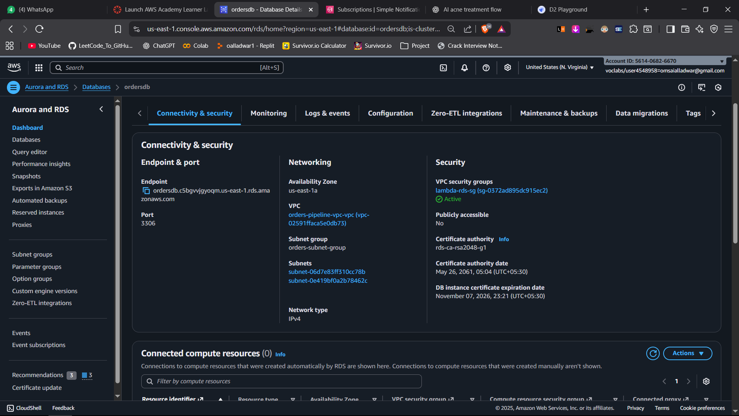

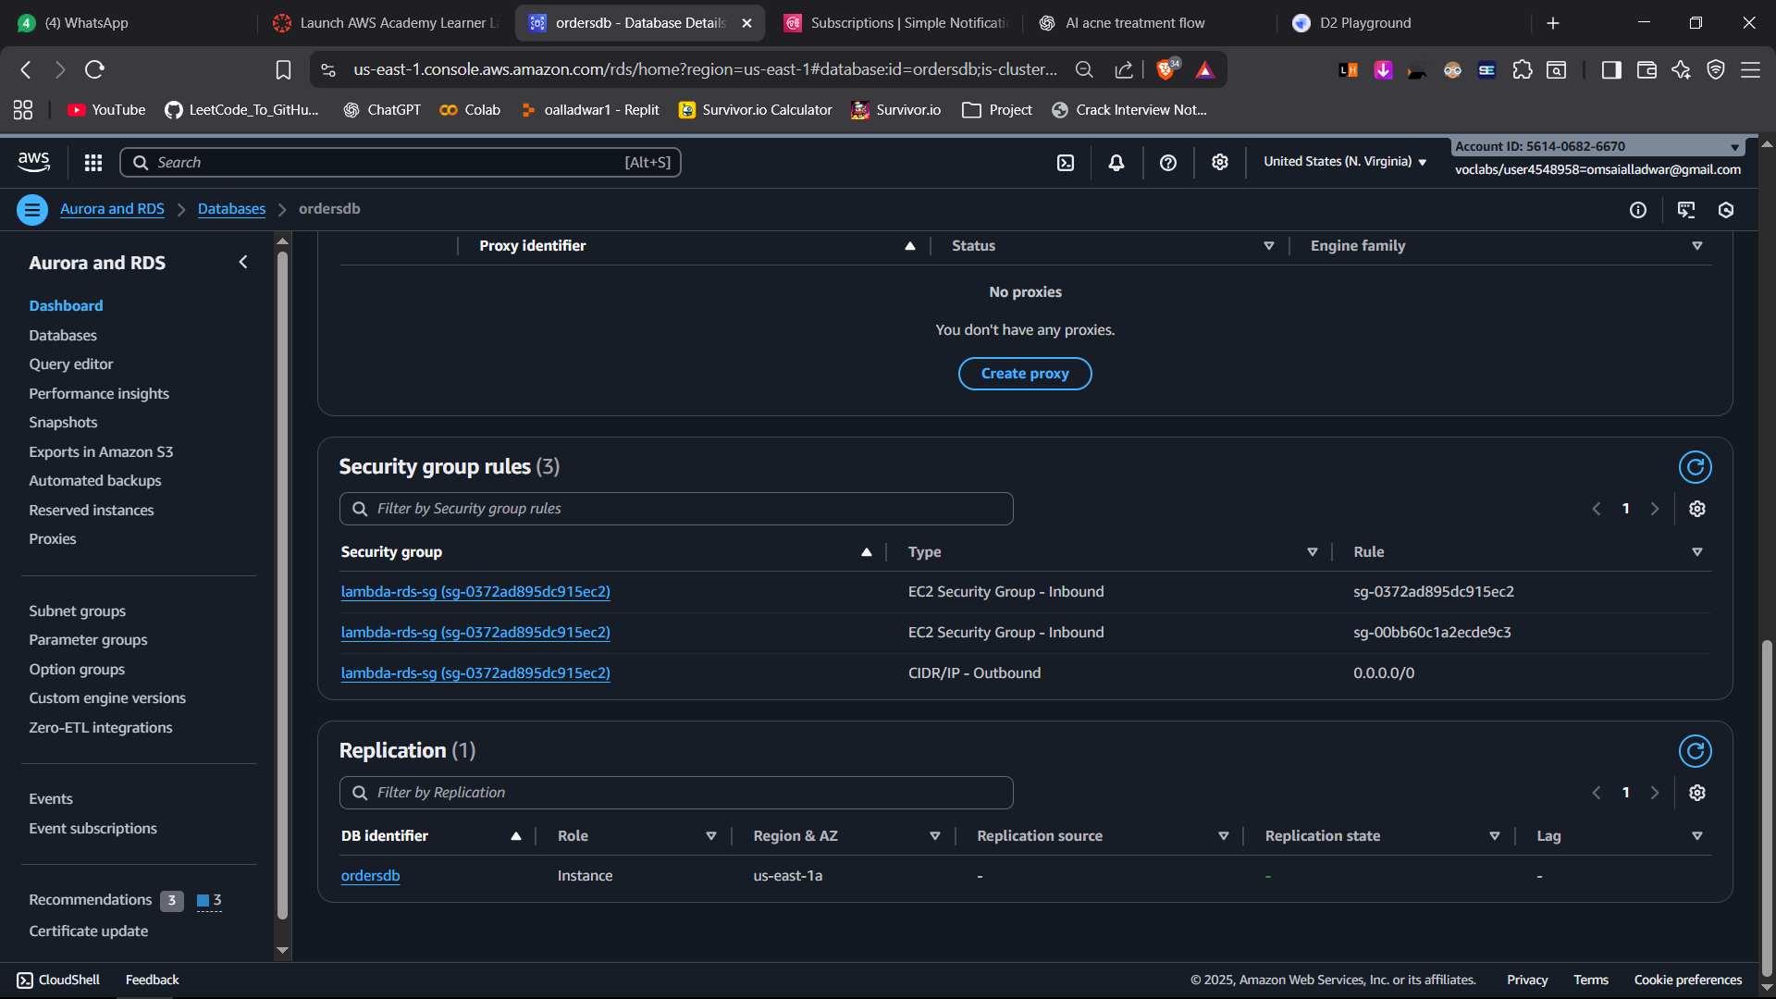

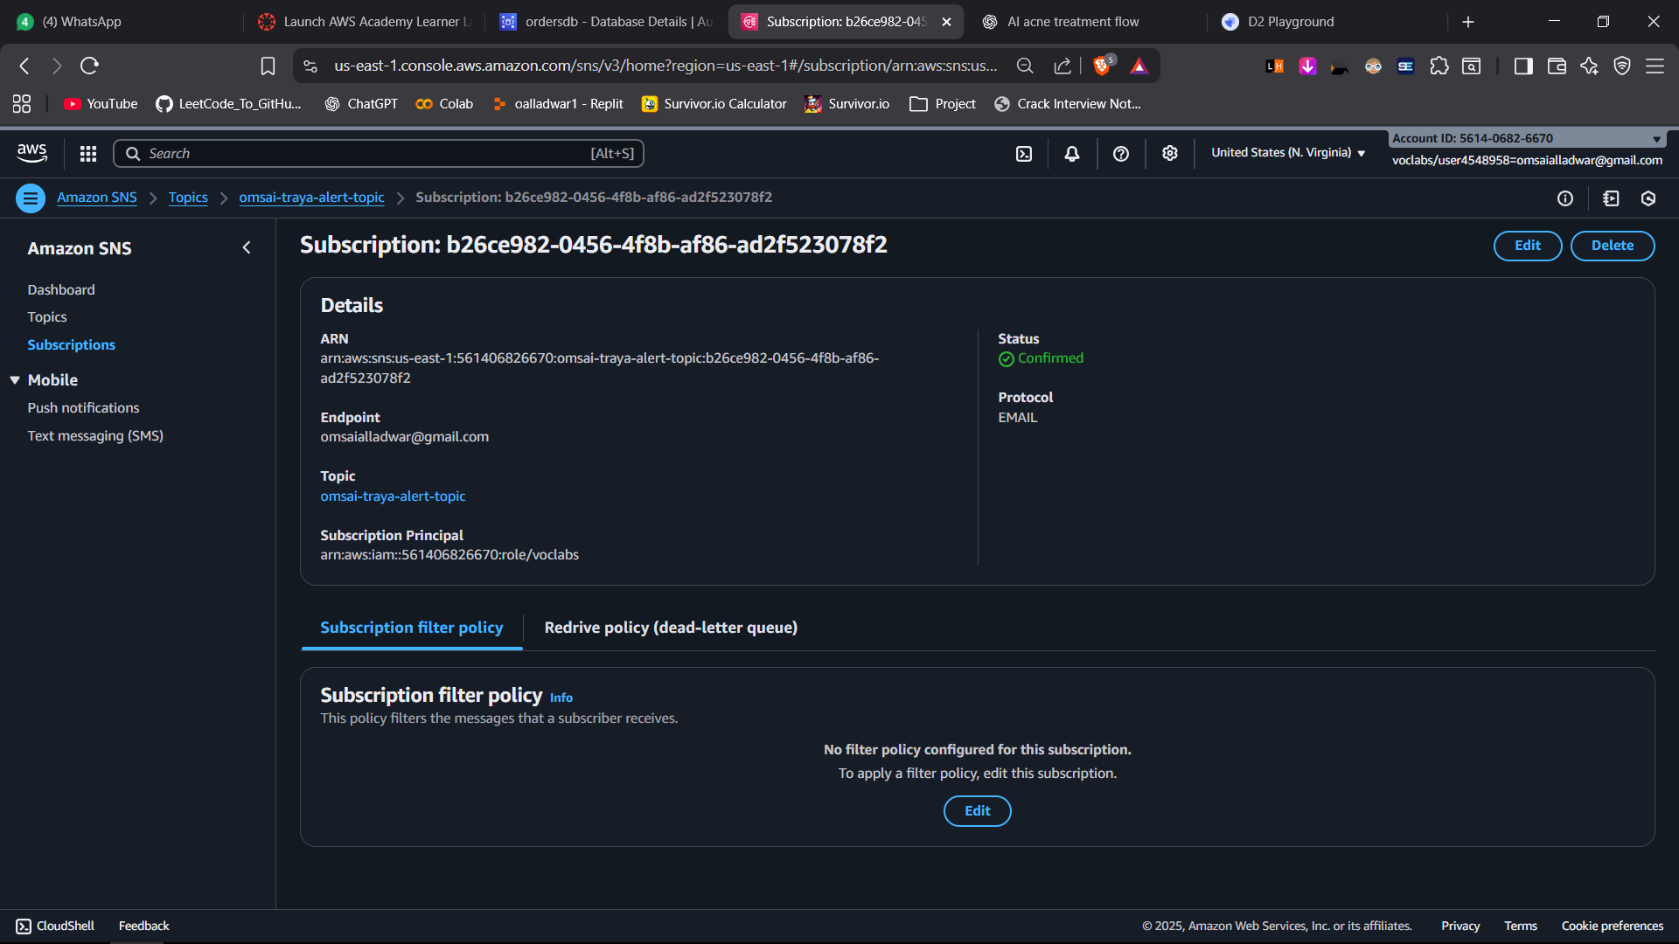

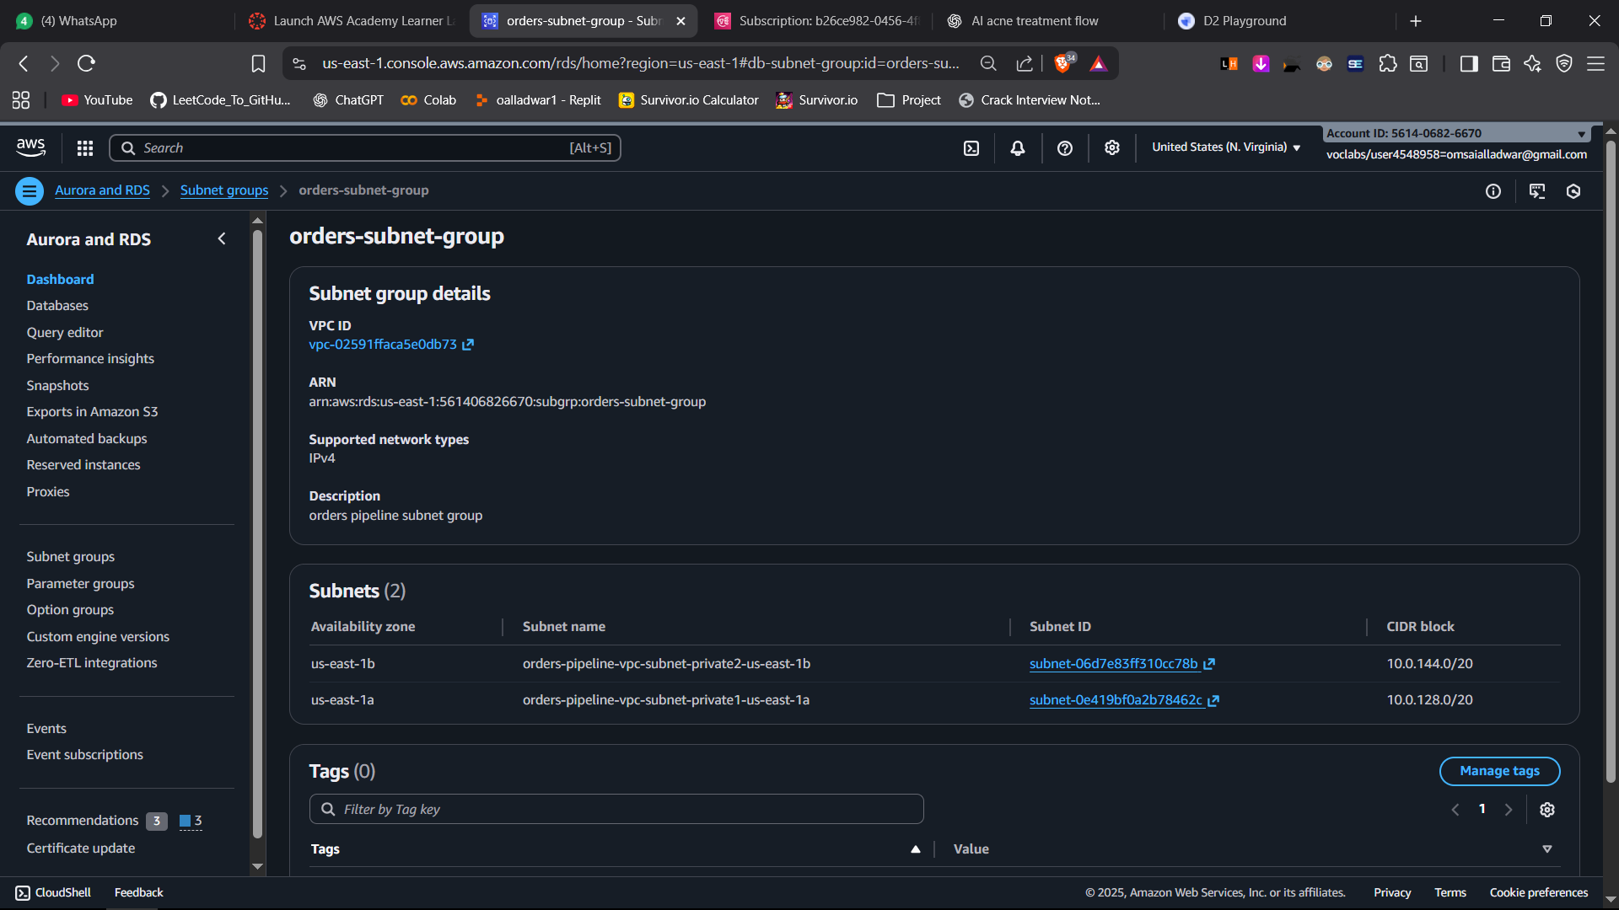

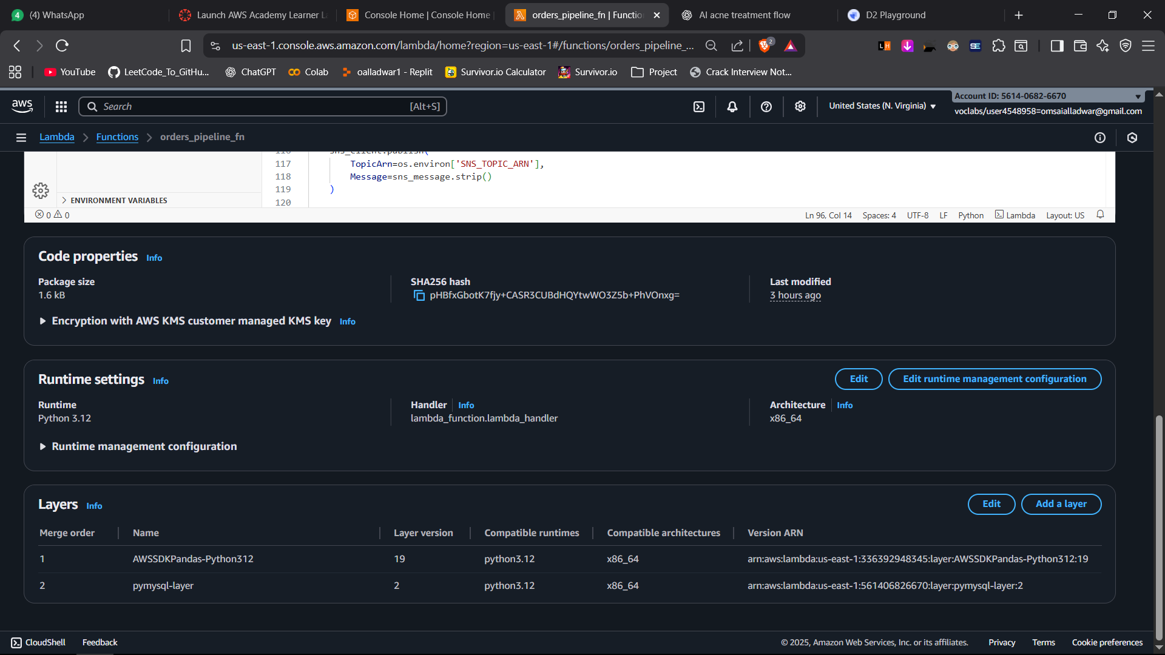

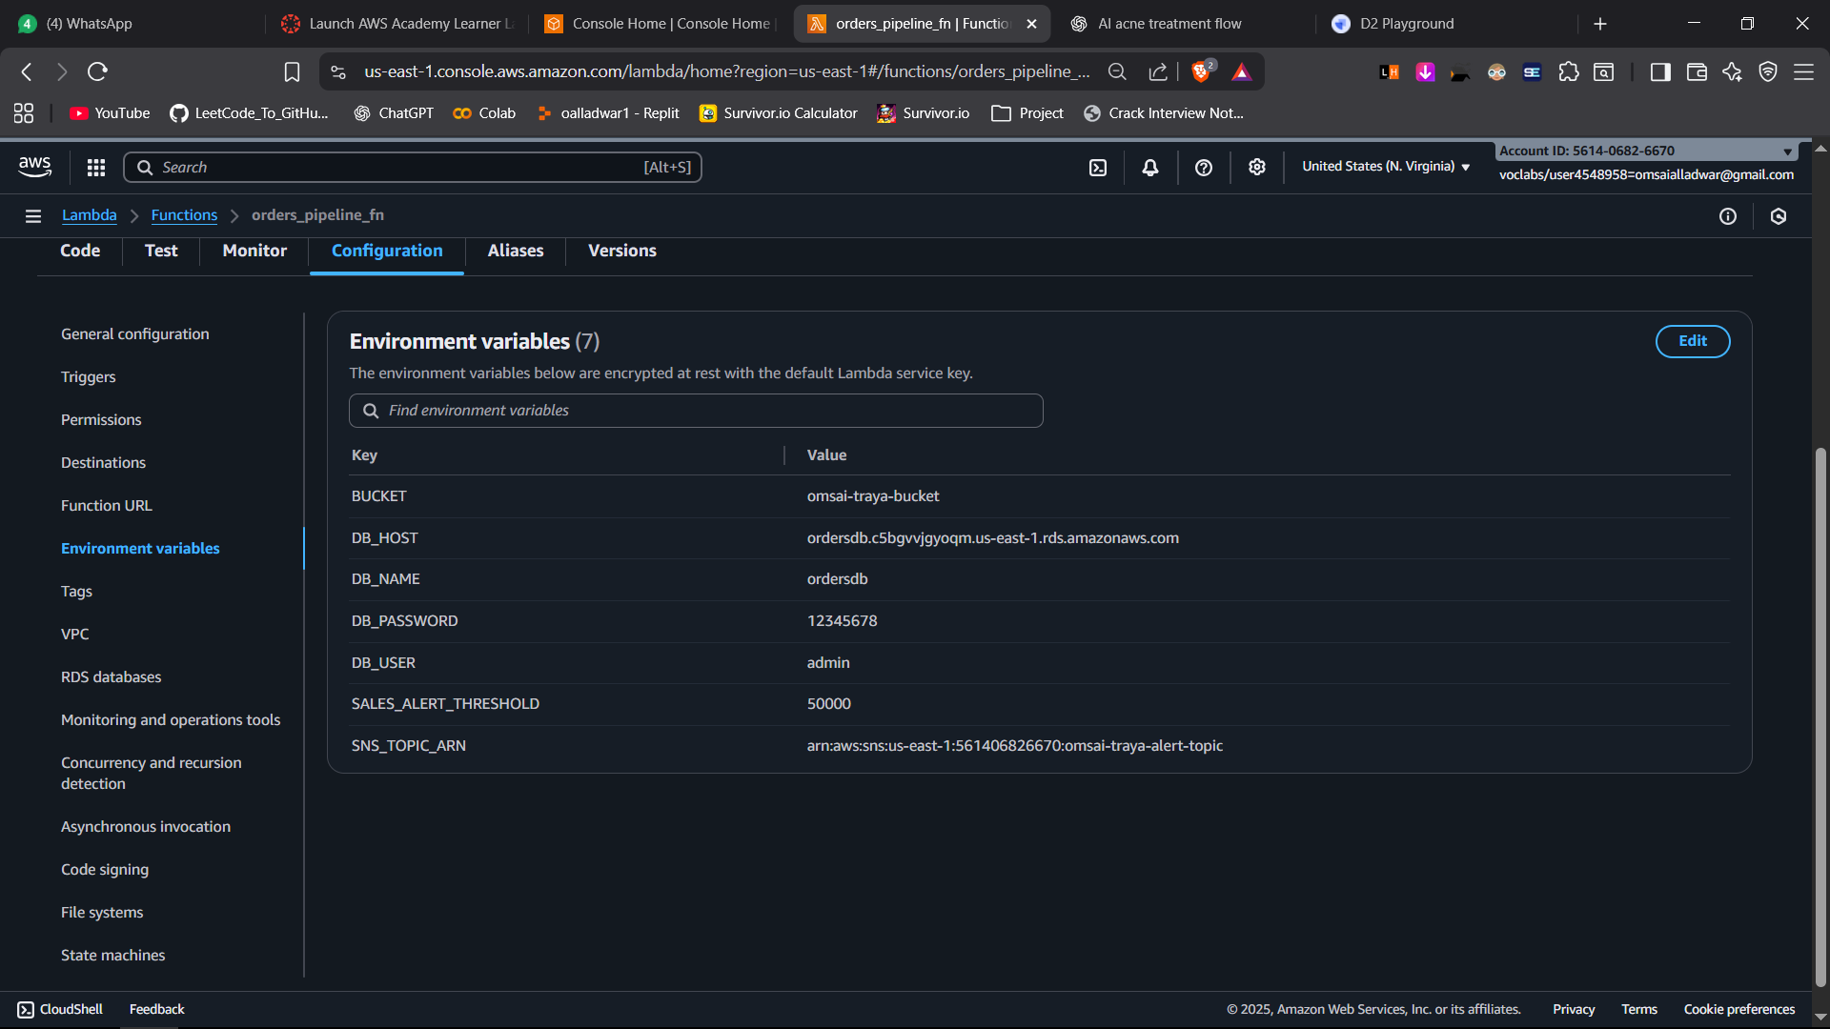

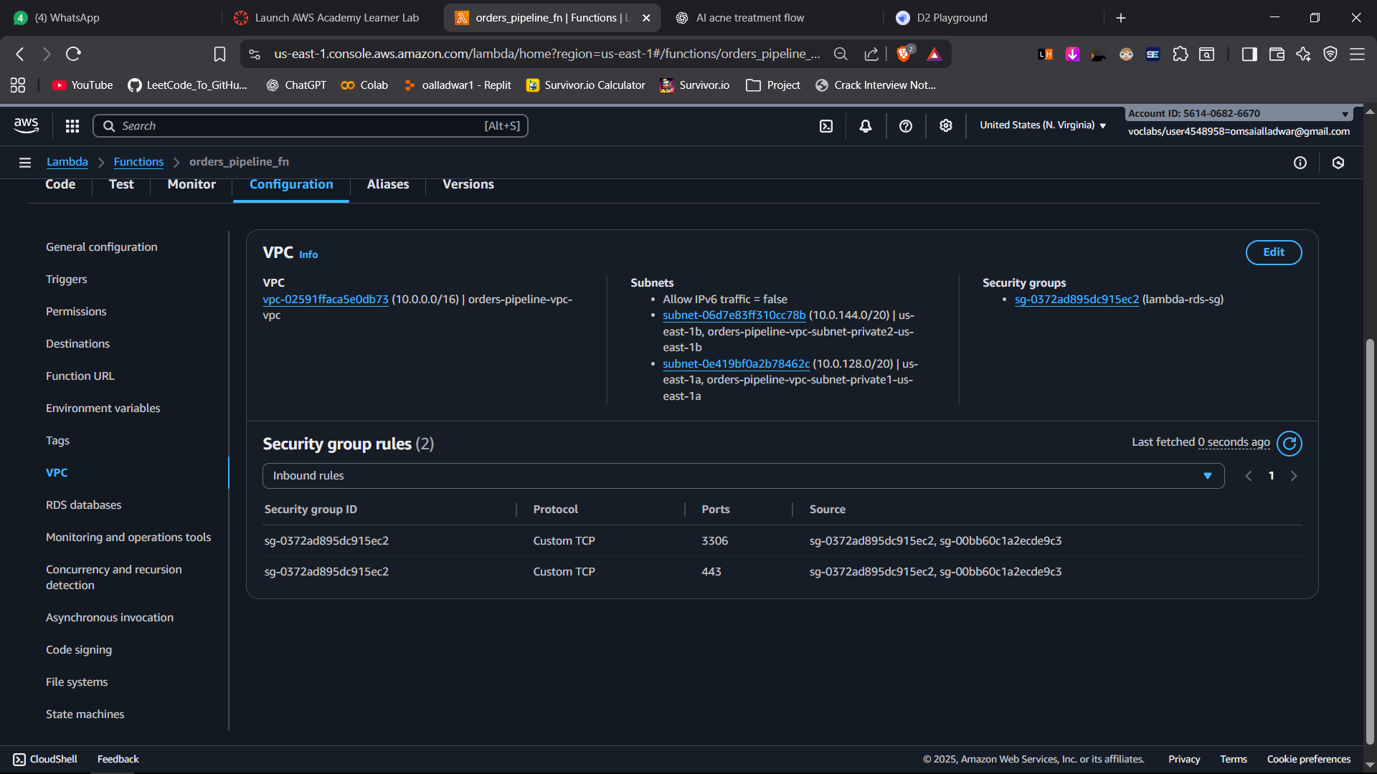

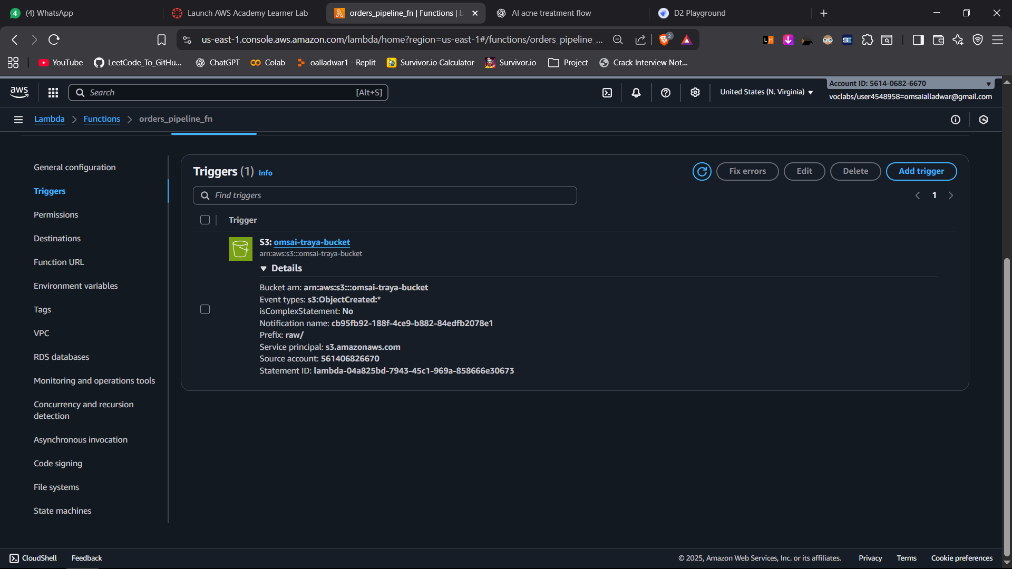

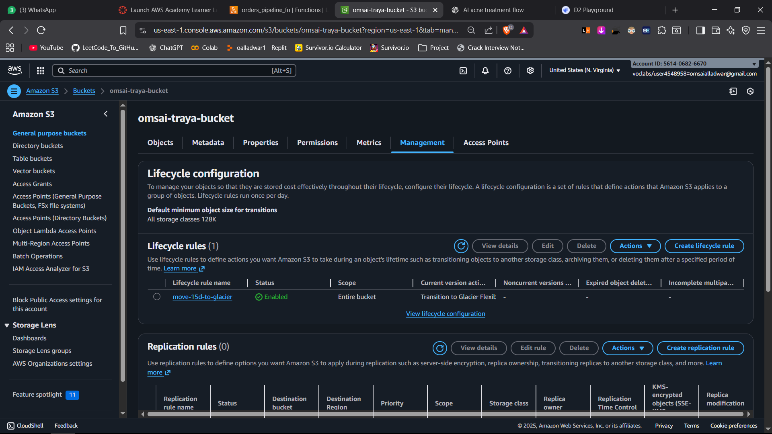

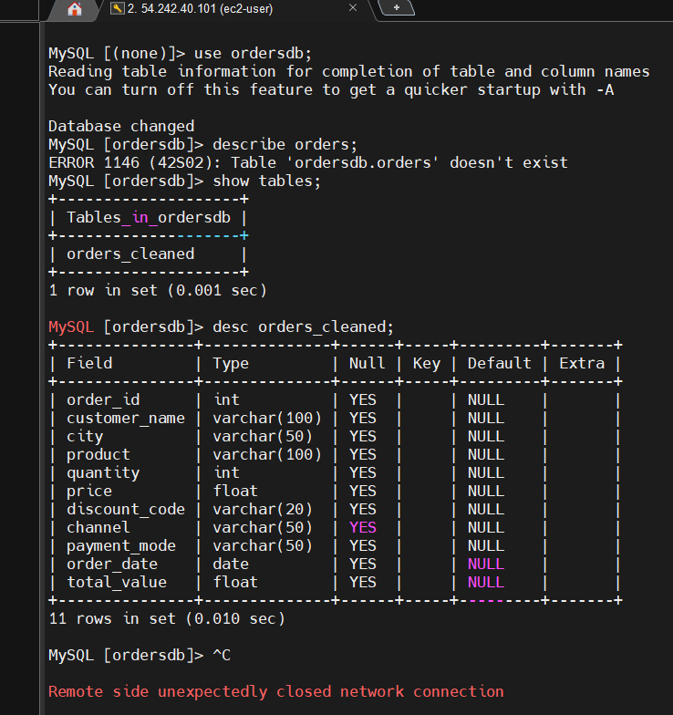

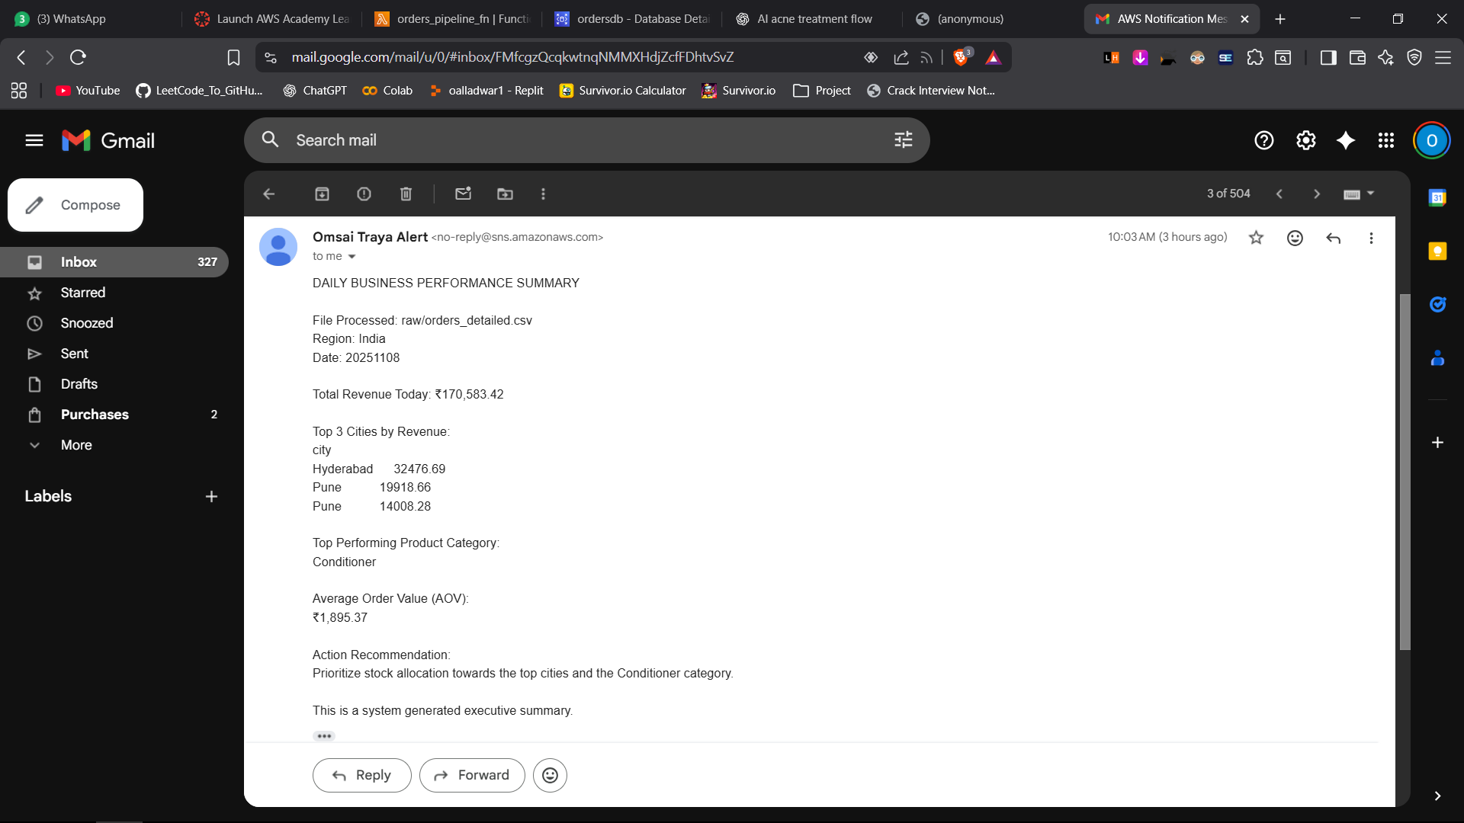

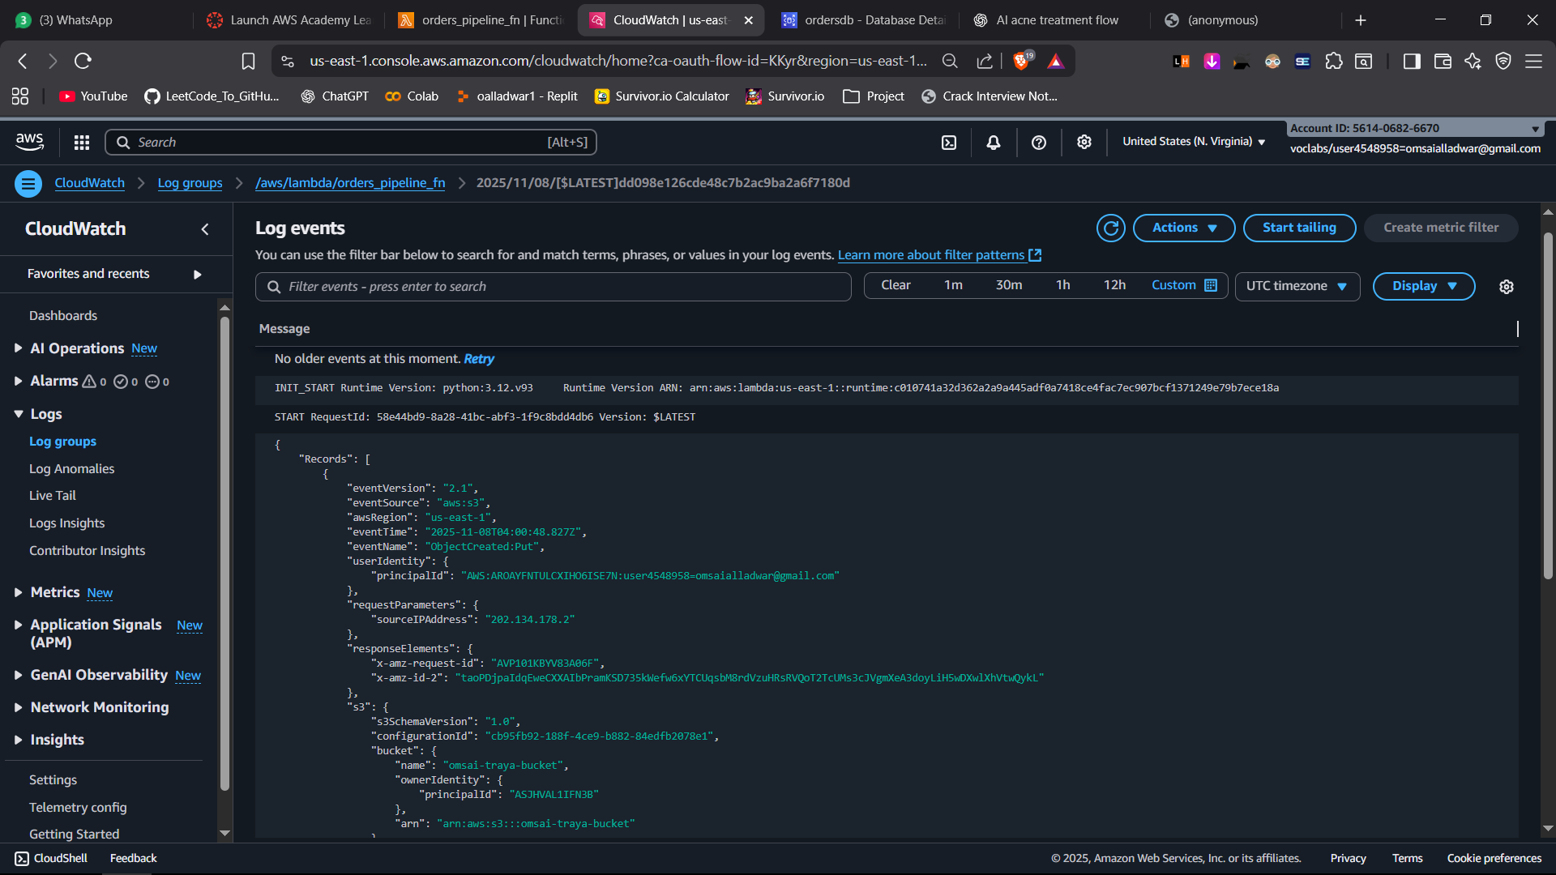

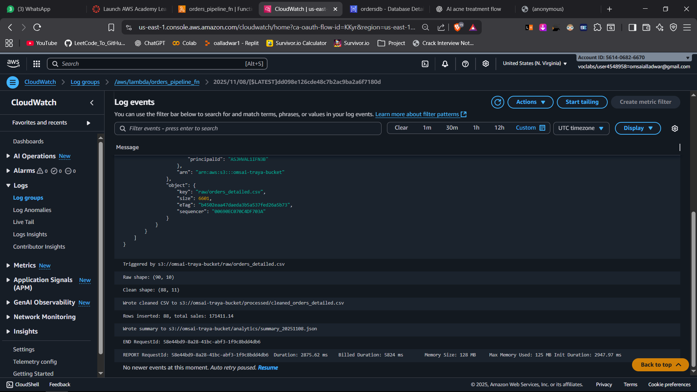

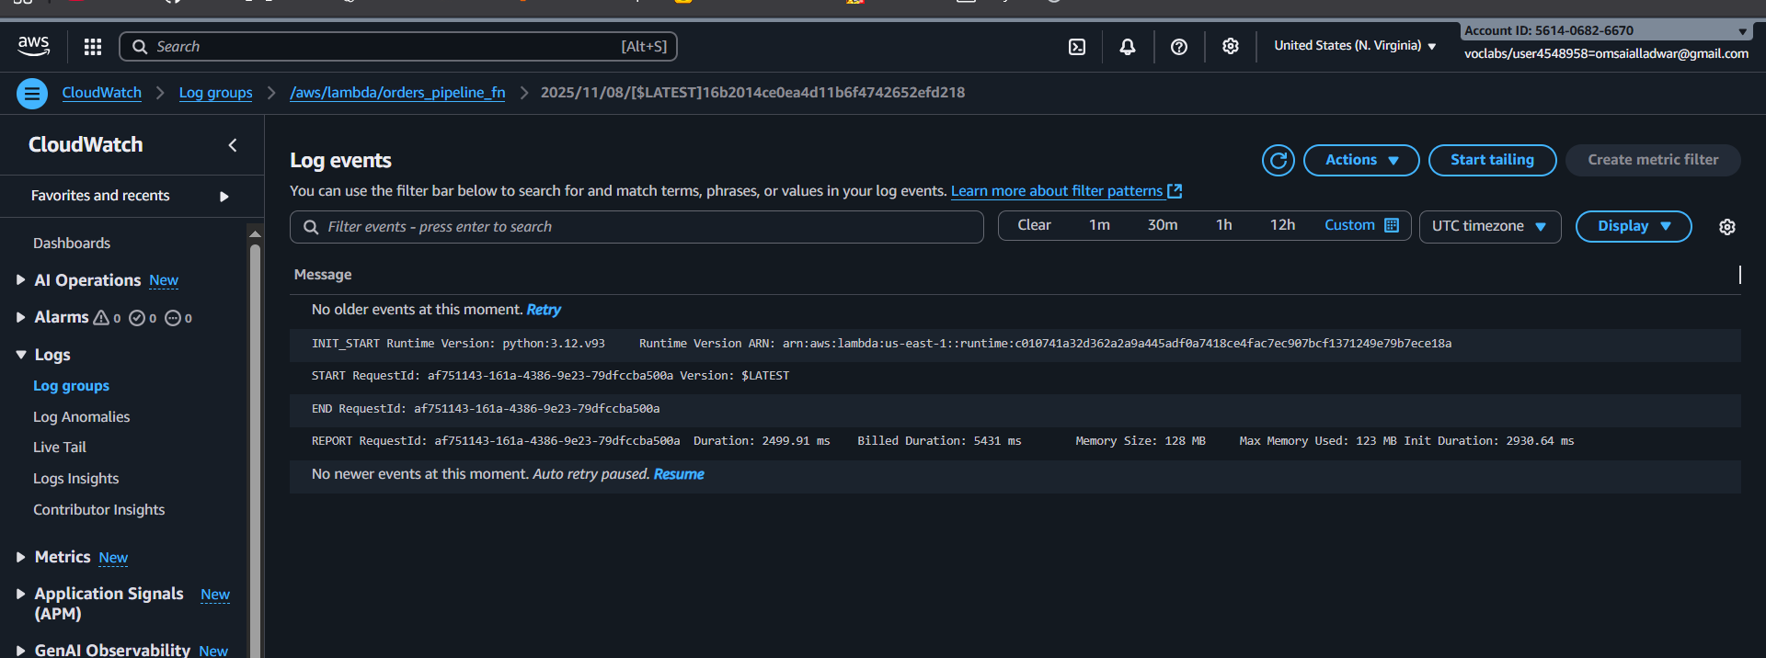

Lambda Code

import json

import boto3

import pandas as pd

import pymysql

import io

import os

from datetime import datetime

def fmt_inr(x):

return "₹{:,.2f}".format(x)

s3 = boto3.client('s3')

sns_client = boto3.client('sns')

def lambda_handler(event, context):

# 1) GET S3 object that triggered

record = event['Records'][0]

bucket = record['s3']['bucket']['name']

key = record['s3']['object']['key']

# get file from s3

obj = s3.get_object(Bucket=bucket, Key=key)

df_raw = pd.read_csv(io.BytesIO(obj['Body'].read()))

# 2) CLEAN DATA

df_raw['total_value'] = df_raw['quantity'] * df_raw['price']

df_clean = df_raw.copy()

# *** FIX NaN ***

df_clean = df_clean.fillna(0)

df_clean = df_clean.where(pd.notnull(df_clean), None)

# write cleaned to processed folder

cleaned_key = "processed/cleaned_orders_detailed.csv"

csv_buffer = io.StringIO()

df_clean.to_csv(csv_buffer, index=False)

s3.put_object(

Bucket=bucket,

Key=cleaned_key,

Body=csv_buffer.getvalue()

)

# 3) INSERT INTO RDS

conn = pymysql.connect(

host=os.environ['DB_HOST'],

user=os.environ['DB_USER'],

passwd=os.environ['DB_PASSWORD'],

db=os.environ['DB_NAME'],

connect_timeout=10

)

cur = conn.cursor()

# create table if not exists

create_sql = """

CREATE TABLE IF NOT EXISTS orders_cleaned(

order_id int,

customer_name varchar(100),

city varchar(50),

product varchar(100),

quantity int,

price float,

channel varchar(50),

payment_mode varchar(50),

discount_code varchar(20),

order_date date,

total_value float

);

"""

cur.execute(create_sql)

conn.commit()

insert_sql = """INSERT INTO orders_cleaned VALUES (%s,%s,%s,%s,%s,%s,%s,%s,%s,%s,%s)"""

rows = [tuple(x) for x in df_clean.to_numpy()]

cur.executemany(insert_sql, rows)

conn.commit()

# 4) ADVANCED ANALYTICS FOR EXECUTIVE EMAIL

total_revenue = df_clean['total_value'].sum()

city_sales = df_clean.groupby('city')['total_value'].sum().sort_values(ascending=False)

top3 = city_sales.head(3)

category_sales = df_clean.groupby('product')['total_value'].sum().sort_values(ascending=False)

top_category = category_sales.head(1).index[0]

avg_order_value = df_clean['total_value'].mean()

fmt_total = fmt_inr(total_revenue)

fmt_avg = fmt_inr(avg_order_value)

today = datetime.now().strftime("%Y%m%d")

sns_message = f"""

DAILY BUSINESS PERFORMANCE SUMMARY

Region: India

Date: {today}

Total Revenue Today: {fmt_total}

Top 3 Cities by Revenue:

{top3.to_string()}

Top Performing Product Category:

{top_category}

Average Order Value (AOV):

{fmt_avg}

Action Recommendation:

Prioritize stock allocation towards the top cities and the {top_category} category.

This is a system generated executive summary.

"""

sns_client.publish(

TopicArn=os.environ['SNS_TOPIC_ARN'],

Message=sns_message.strip()

)

# 5) WRITE SUMMARY JSON TO S3

summary_obj = {

"date": today,

"total_revenue": total_revenue,

"top_3_cities": top3.to_dict(),

"top_category": top_category,

"avg_order_value": avg_order_value

}

summary_key = f"analytics/summary_{today}.json"

s3.put_object(

Bucket=bucket,

Key=summary_key,

Body=json.dumps(summary_obj, indent=2)

)

return {

"statusCode": 200,

"body": "Pipeline success"

}

Cron code :

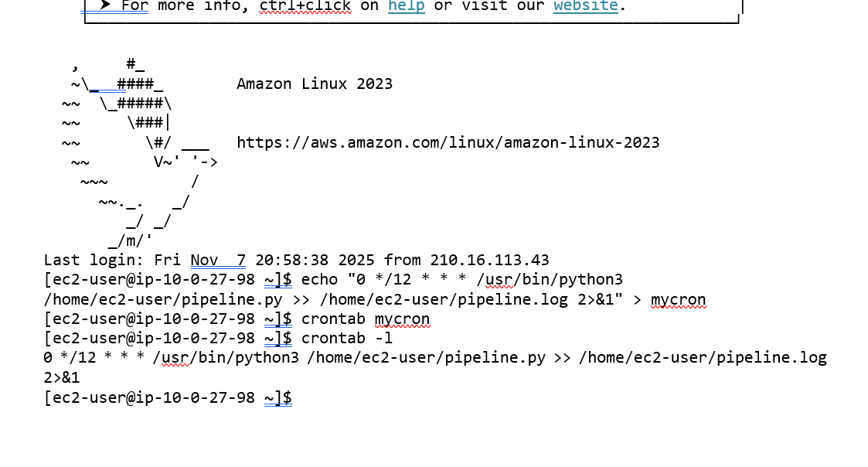

Json file :

